**Class Project 2**

Use two images for each operation to do the following operations and write down their advantages and disadvantages and explain your results:

1. **Image reduction(lena, bridge, noise):**

* Alternative line reduction

**Algorithm:**

AlterReduct(image num)// num is the reduced magnification of the picture

integer i from 0 to height/num, i plus 1,

integer j from 0 to width/num, j plus 1,

$$outData[i*width/num+j]=indata[num*width*i+num*j]$$

**Results (including pictures):**

Result of processing “Lena.pgm”:

Source Image: Result after alternative line reduction:

(2 times reduction)

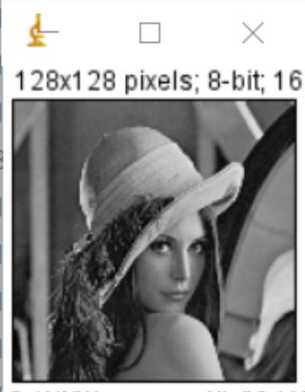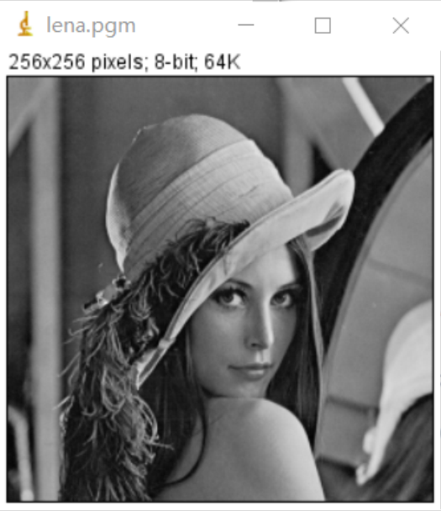

Result of processing “bridge.pgm”:

Source Image: Result after alternative line reduction:

(2 times reduction)

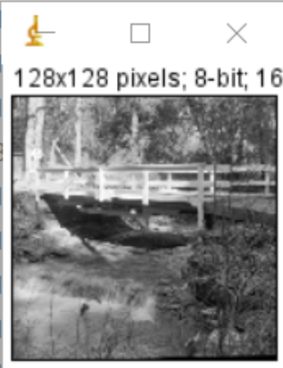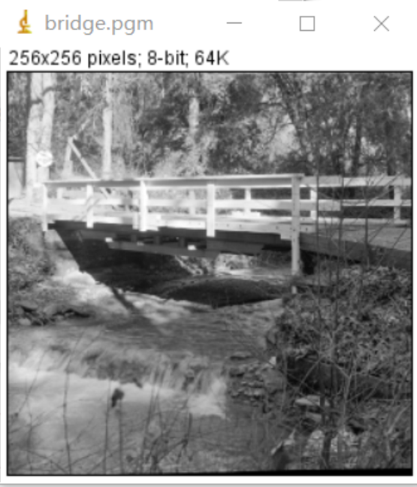

Result of processing “noise.pgm”:

Source Image: Result after alternative line reduction:

(2 times reduction)

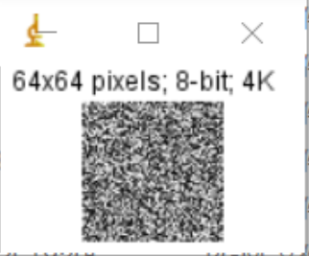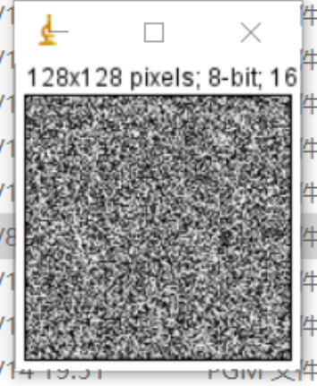

**Discussion:**

This algorithm deletes one line at every interval and re-splices the processed pixel blocks, resulting in a smaller picture size. Its advantage is that the algorithm is simple, easy to understand and calculate. The disadvantage is that a large amount of data is lost, resulting in large-scale distortion of the image.

**Codes:**

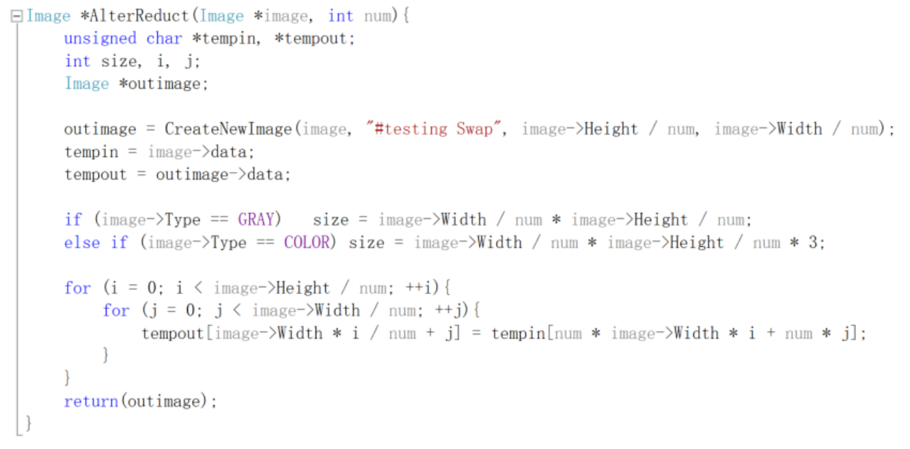

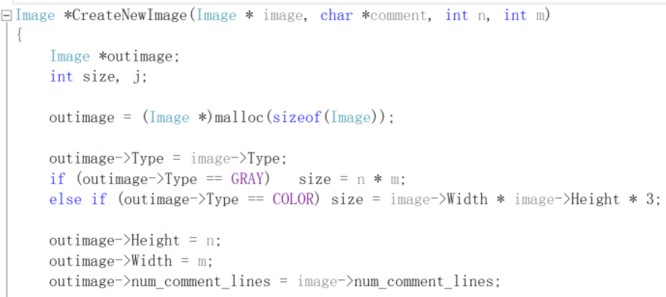

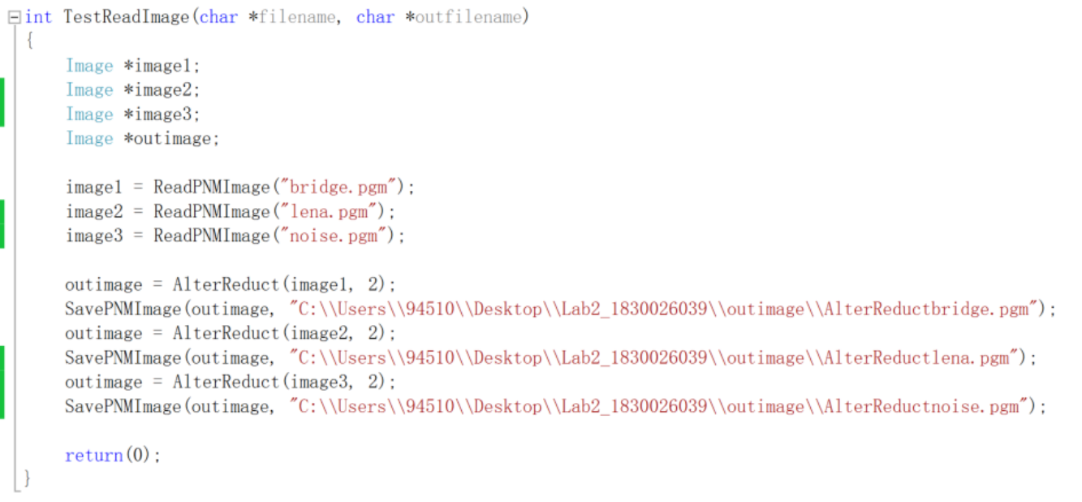

* Fractional linear reduction to reduce images

**Algorithm:**

It is the same as the nearest neighbor interpolation algorithm, except that the input value becomes a float, making it a fractional multiple. The calculation formula is:

FLR(image, h, w) //h and w are the reduced magnification of height and weight.

integer i from 0 to height/num, i plus 1,

integer j from 0 to width/num, j plus 1,

$$outData[i*outimageWidth+j]=indata[round(i*ratioH)*width+ratioW*j]$$

**Results (including pictures):**

Result of processing “Lena.pgm”:

Source Image: Result after fractional linear reduction:

(height: 0.88, width: 0.4)

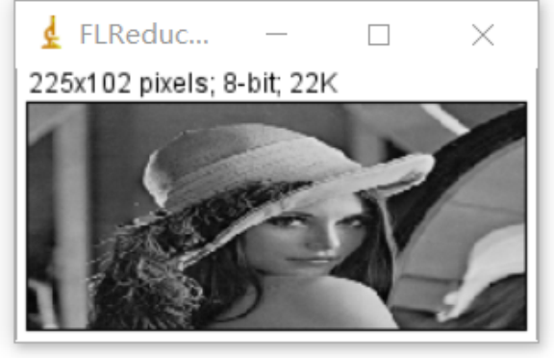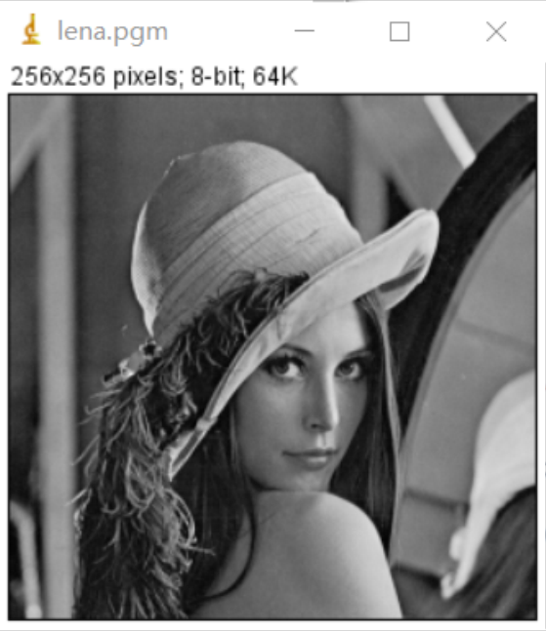

Result of processing “bridge.pgm”:

Source Image: Result after fractional linear reduction:

(height: 0.4, width: 0.88)

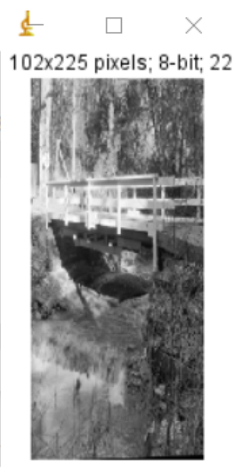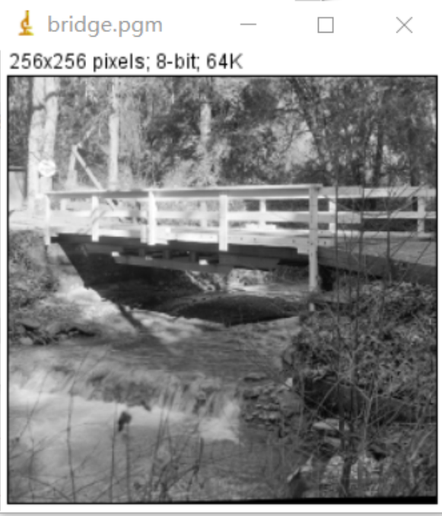

Result of processing “noise.pgm”:

Source Image: Result after fractional linear reduction:

(height: 0.75, width: 0.75)

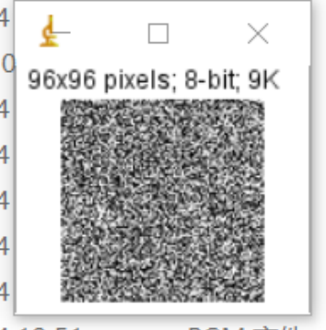

**Discussion:**

This algorithm is the same as the nearest neighbor interpolation algorithm, except that this algorithm can adjust the length and width separately, and can be a fractional multiple. The nearest neighbor interpolation calculation is relatively small, but it may cause discontinuities in the gray level of the image generated by the interpolation, and obvious jaggedness may appear at the place where the gray level changes.

**Codes:**

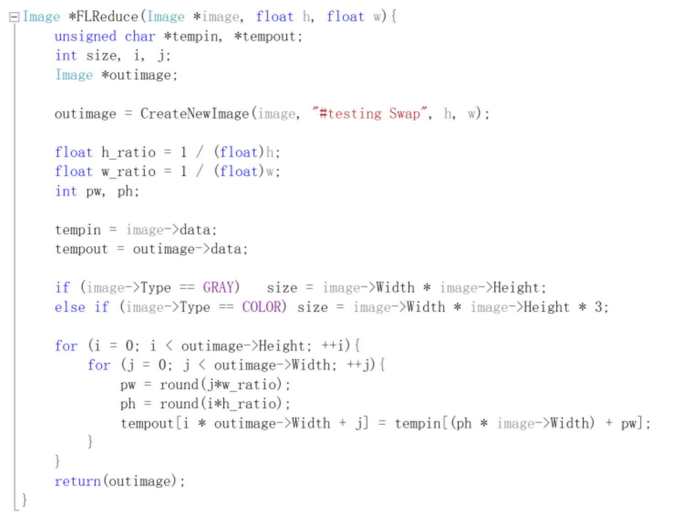

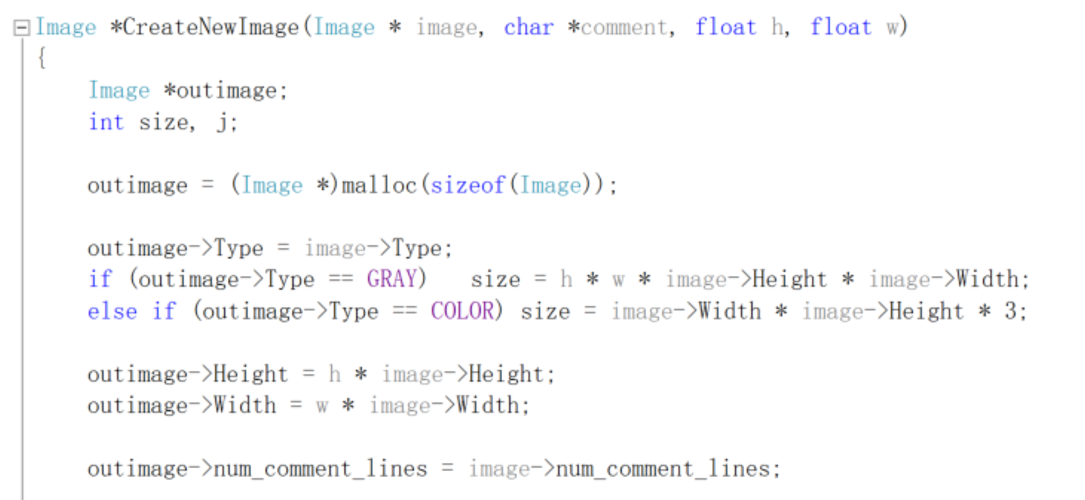 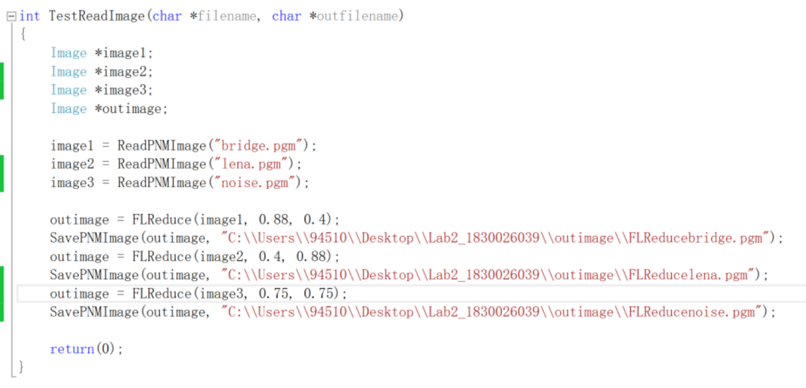

1. **Image reduction(lena, bridge, noise):**

* Pixel replication
* **Algorithm:**

B

B

B

D

D

B

D

B

B

D

D

B

D

B

B

D

D

B

D

A

A

C

C

A

C

A

A

C

C

A

C

A

A

D

A

C

3 TIMES

A

C

C

C

num is the magnification of the picture,

integer k and t,

When k<num, k plus 1, it used to check the height which have been printed in a new pgm file.

When t<num, t plus, it used to check the width which have been printed in a new pgm file.

$$outData[(k+num*i)*width+(t+num*j)]=indata[width*i+j]$$

**Results (including pictures):**

Result of processing “Lena.pgm”:

Source Image: Result after pixel replication: (2 times)

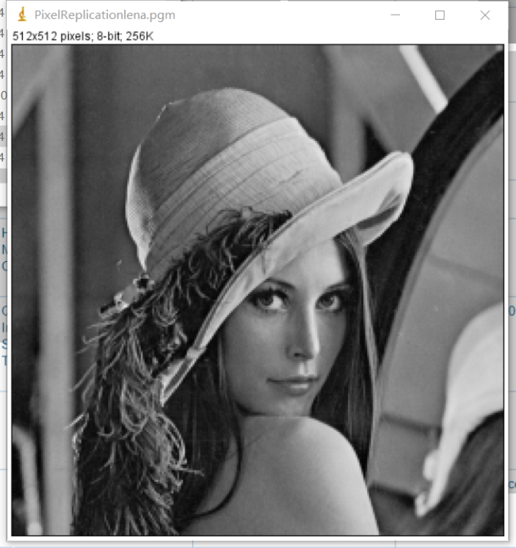

Result of processing “bridge.pgm”:

Source Image: Result after pixel replication: (2 times)

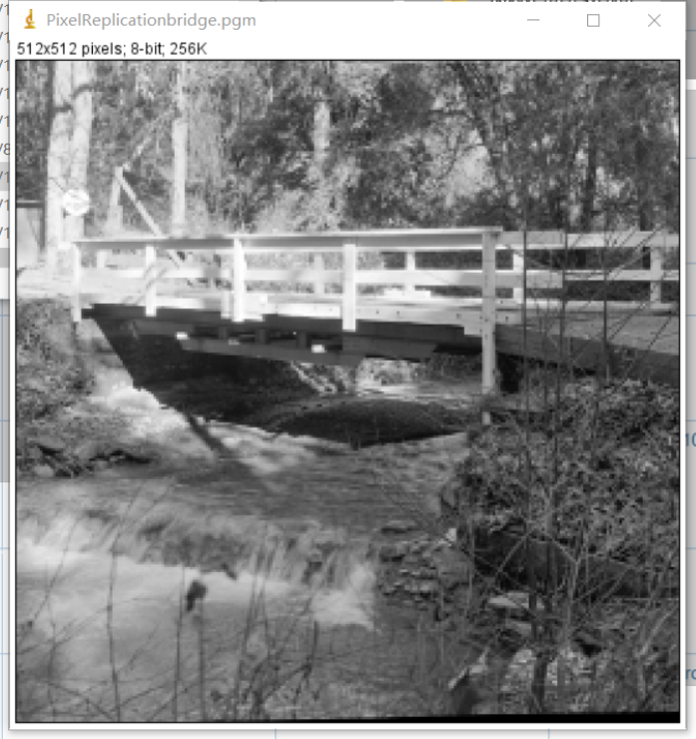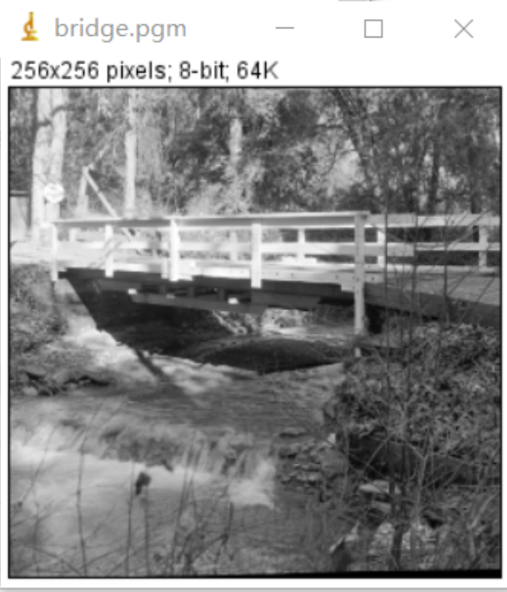

Result of processing “noise.pgm”:

Source Image: Result after pixel replication: (2 times)

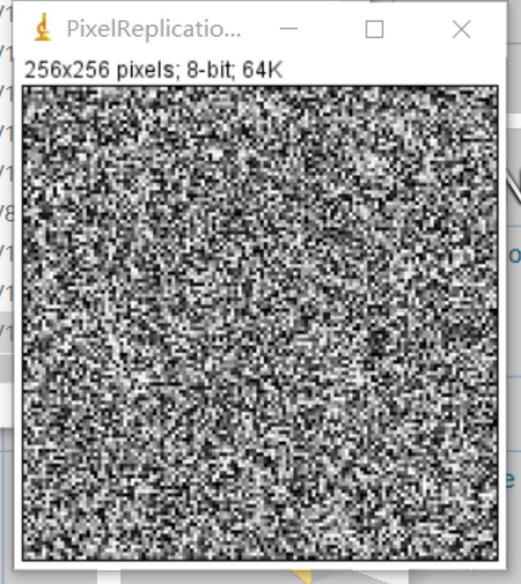

**Discussion:**

This algorithm turns the original pixel block into a multiple of square pixel blocks, and the pixels of each block are the same as the original pixels. Finally, the copied pixel blocks are re-spliced to make the image larger. The advantage is that the algorithm is simple and easy to understand. The disadvantage is that simple copying makes the image blurry when the image becomes larger.

**Codes:**

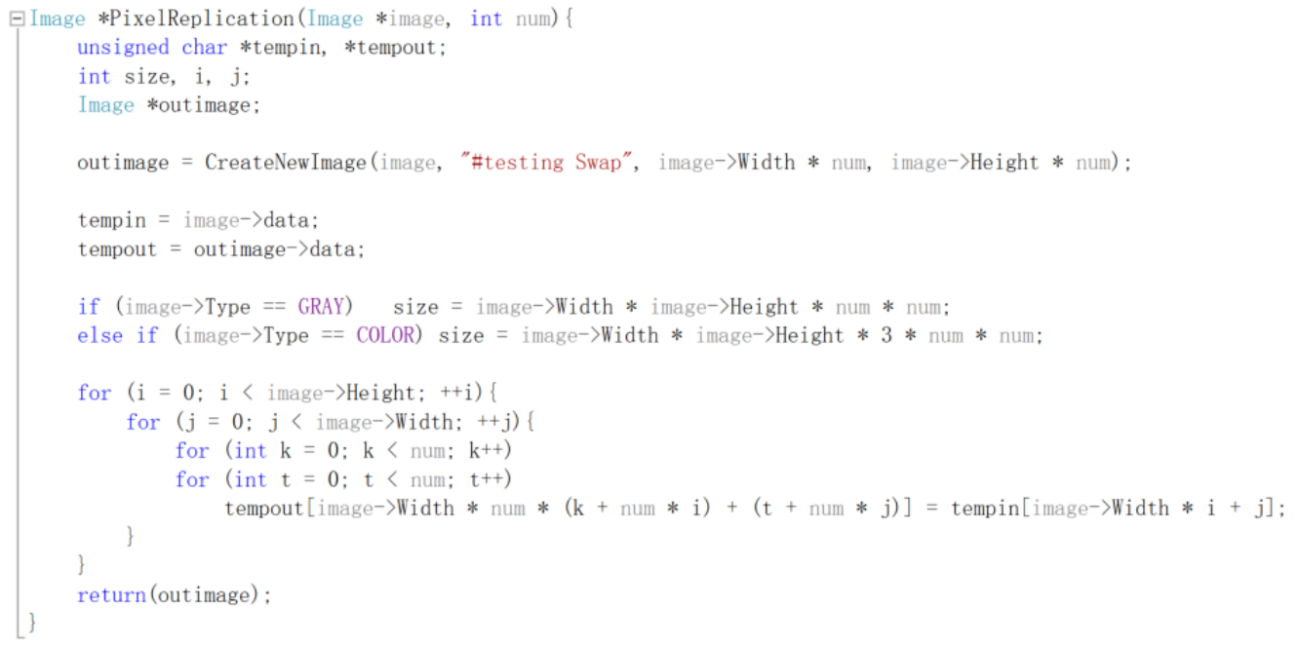

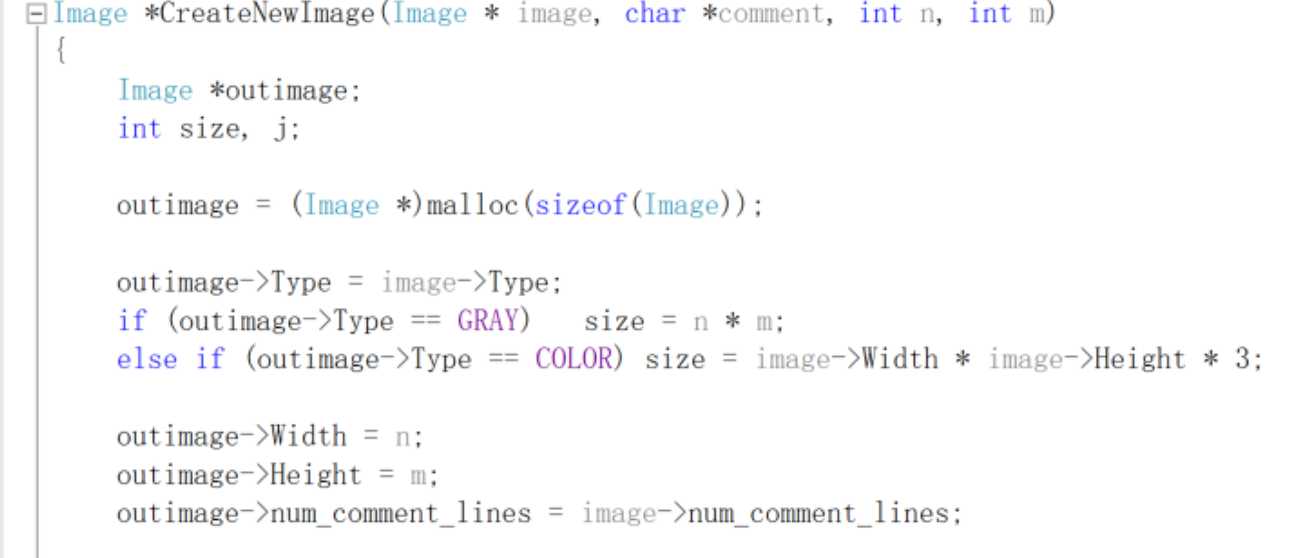

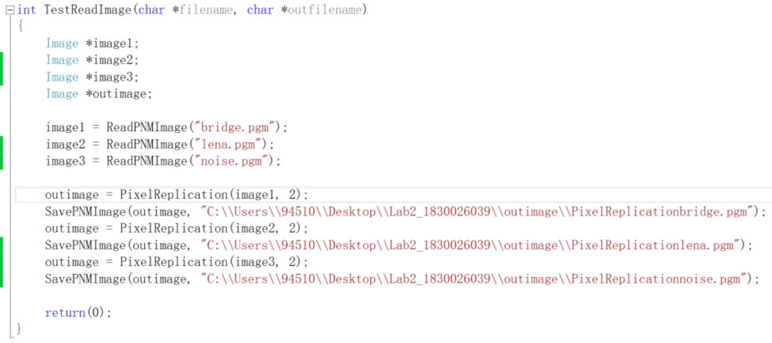

* Nearest enlargement

**Algorithm:**

Calculate the pixel value of the coordinate point of the new image corresponding to the pixel value of which coordinate point in the original image to fill. The calculation formula is:

$$ratio=\left(\frac{imageWidth}{outimageWidth}\right)=\left(\frac{imageHeight}{outimageHeight}\right)$$

(because the height and width are enlarged for the same magnification)

Round to the nearest integer and use the round function in the header file math.h.

Near(image, x) //x is the reduced magnification of the picture

integer i from 0 to height/num, i plus 1,

integer j from 0 to width/num, j plus 1,

$$outData[i*outimageWidth+j]=indata[round(i*ratio)*width+ratio*j]$$

**Results (including pictures):**

Result of processing “Lena.pgm”:

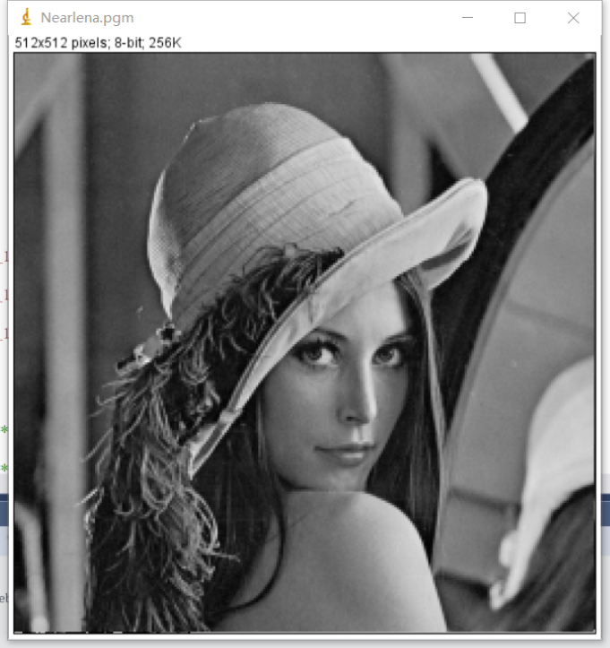Source Image: Result after nearest enlargement: (2 times)



Result of processing “bridge.pgm”:

Source Image: Result after nearest enlargement: (3 times)

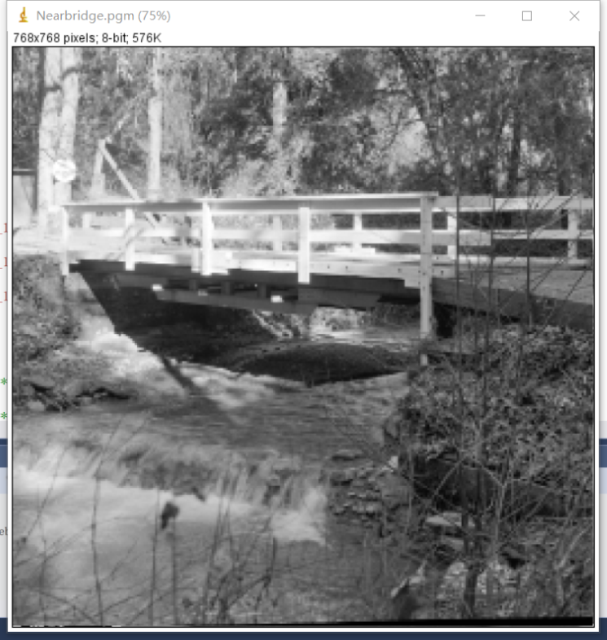

Result of processing “noise.pgm”:

Source Image: Result after nearest enlargement: (2 times)

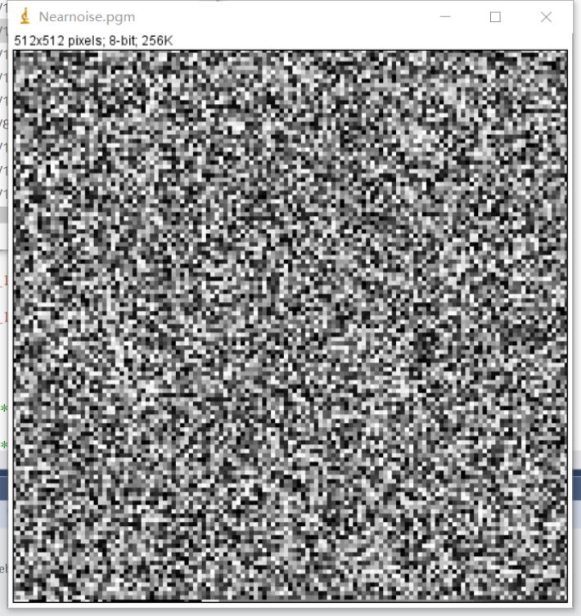



**Discussion:**

The nearest neighbor interpolation calculation is relatively small, but it may cause discontinuities in the gray level of the image generated by the interpolation, and obvious jaggedness may appear at the place where the gray level changes.

**Codes:**

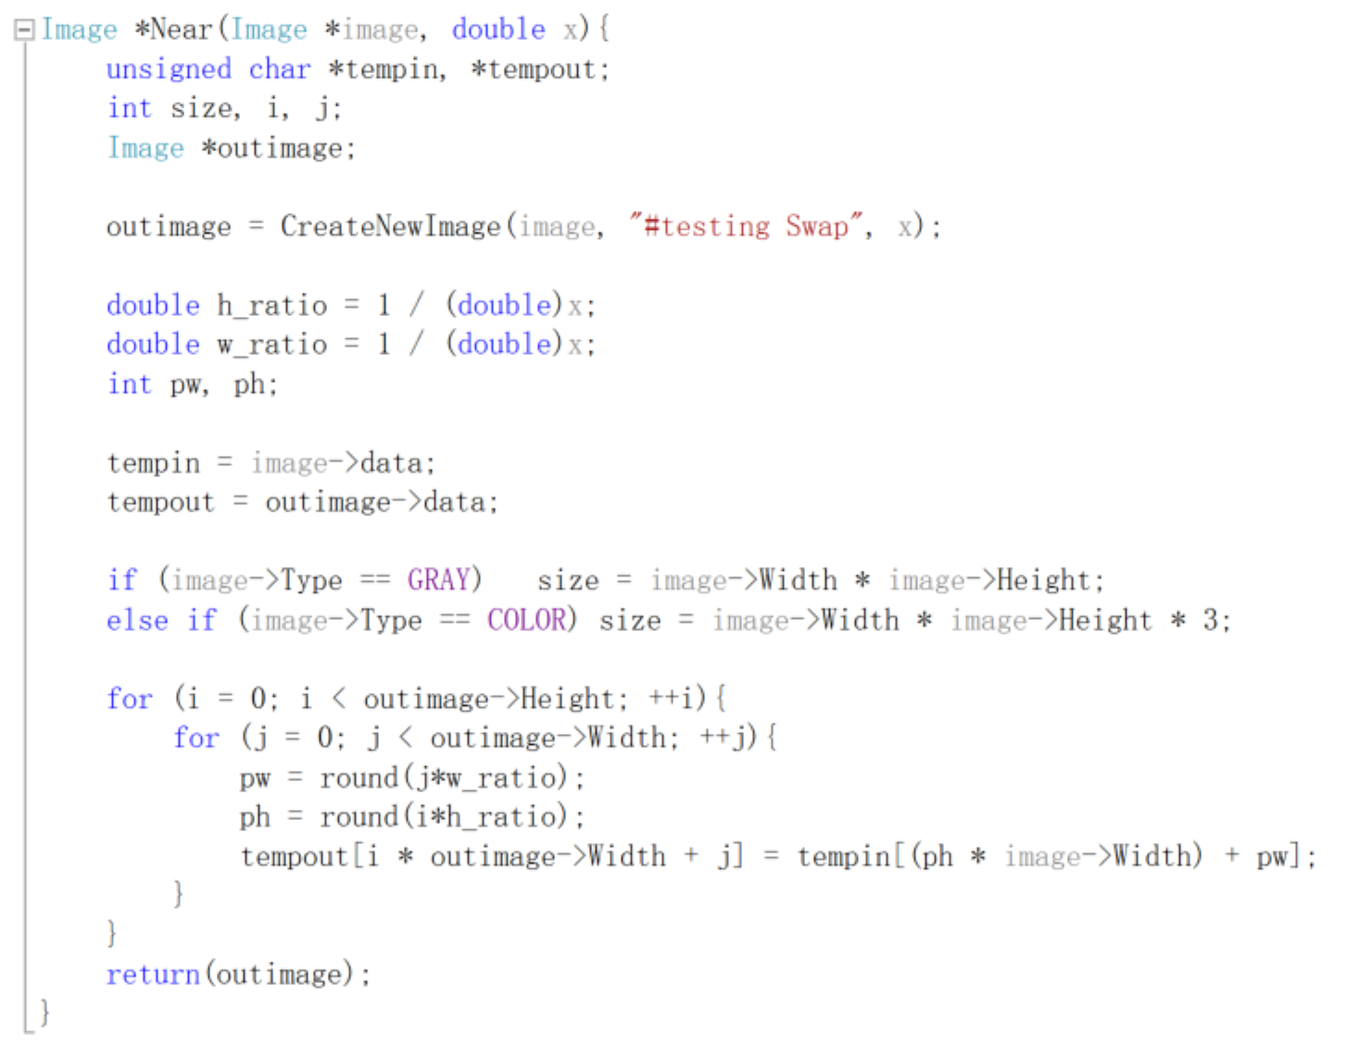

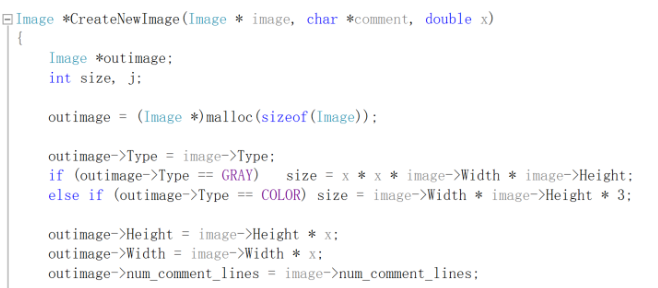

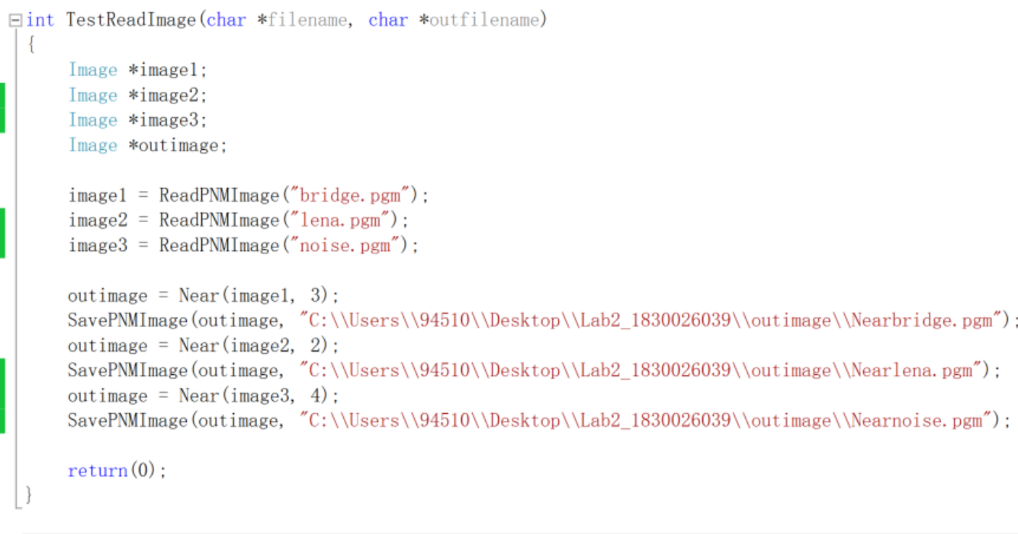

* Bilinear interpolation

**Algorithm:**

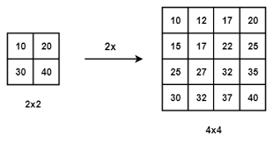

Suppose the size of the source image is m*n and the target image is a*b. Then the side length ratios of the two images are: m/a and n/b. Note that usually this ratio is not an integer, and a floating point type should be used when programming and storing. The (i,j)th pixel of the target image (row i and column j) can be mapped back to the source image through the side length ratio. The corresponding coordinates are (i*m/a, j*n/b).

Obviously, the corresponding coordinates are generally not integers, and non-integer coordinates cannot be used on discrete data such as images. Bilinear interpolation calculates the value (grayscale value or RGB value) of the point by finding the four pixels closest to the corresponding coordinate. If your corresponding coordinates are (2.5, 4.5), then the nearest four pixels are (2, 4), (2, 5), (3, 4), (3, 5).

If the image is a grayscale image, then the grayscale value of point (i, j) can be calculated by the following formula:

f(i,j)=w1*p1+w2*p2+w3*p3+w4*p4;

**Results (including pictures):**

Result of processing “Lena.pgm”:

Source Image: Result after bilinear interpolation: (2 times)

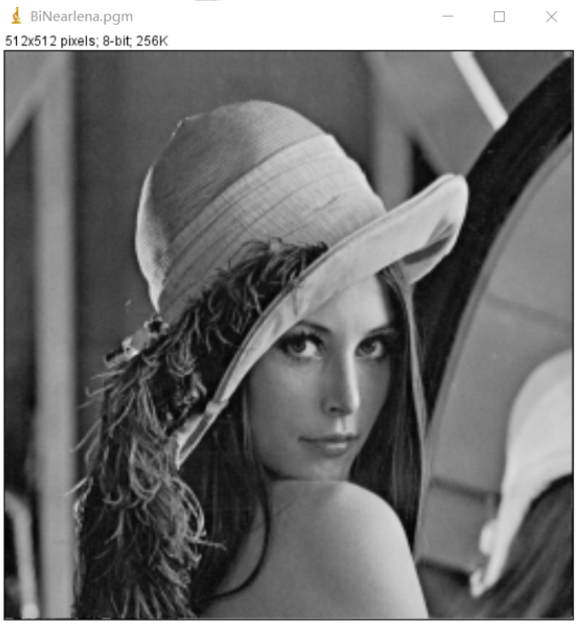

Result of processing “bridge.pgm”:

Source Image: Result after bilinear interpolation: (3 times)

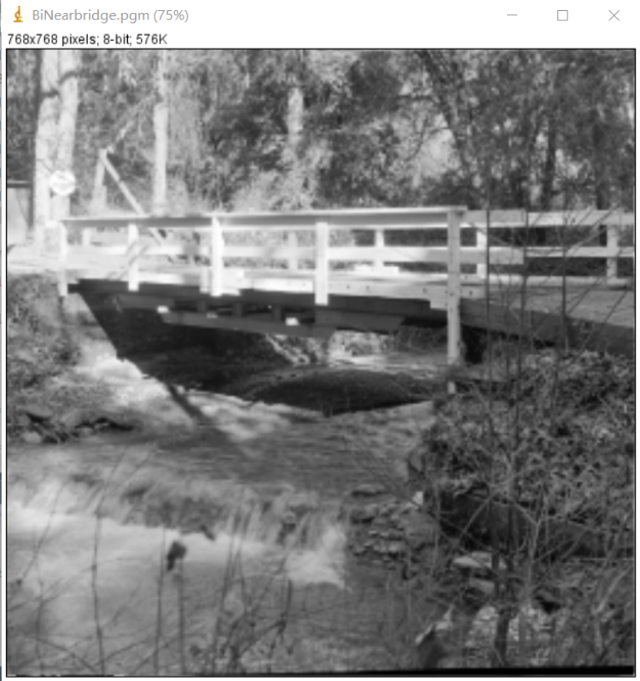

Result of processing “noise.pgm”:

Source Image: Result after bilinear interpolation: (2 times)

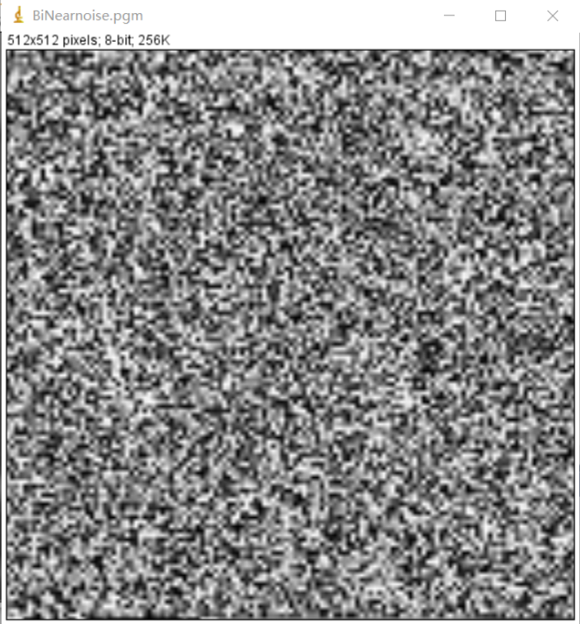



**Discussion:**

The calculation of the bilinear interpolation method is more complicated than the nearest neighbor method, and the calculation amount is larger, but it does not have the shortcoming of gray discontinuity. It has low-pass filtering properties, which damages high-frequency components, and the image outline may be a little blurred. The image looks smoother.

**Codes:**

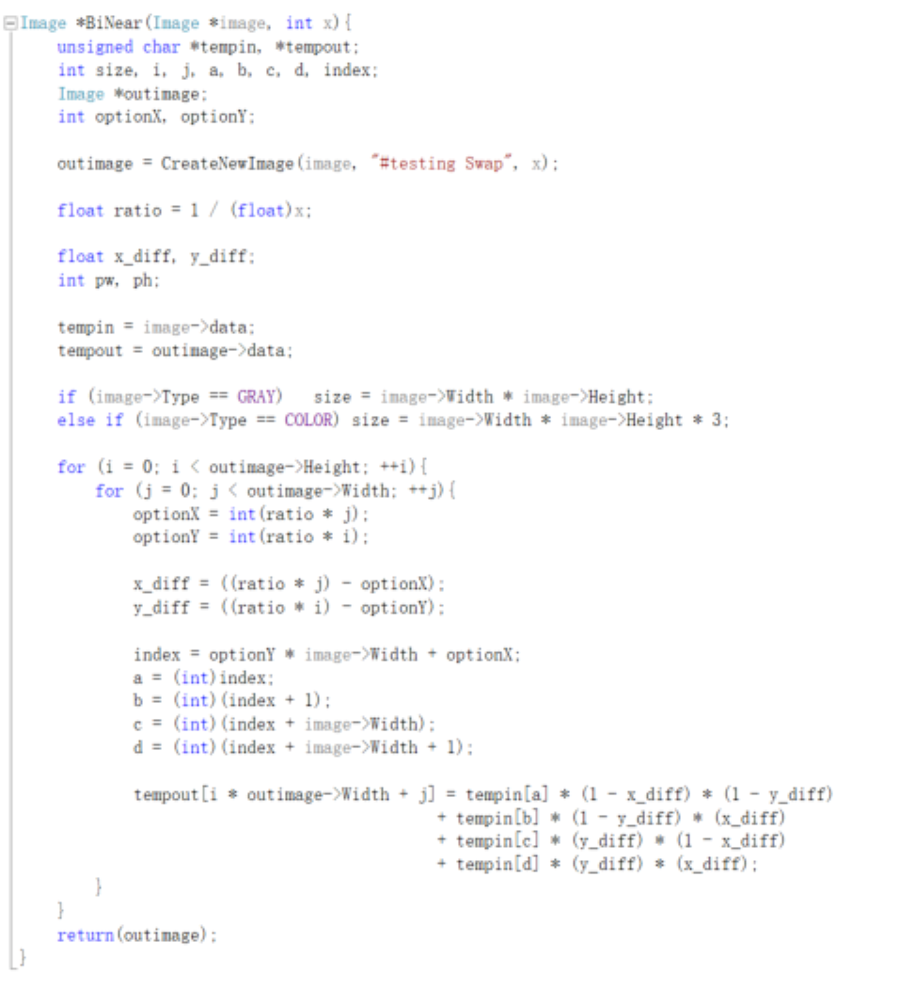 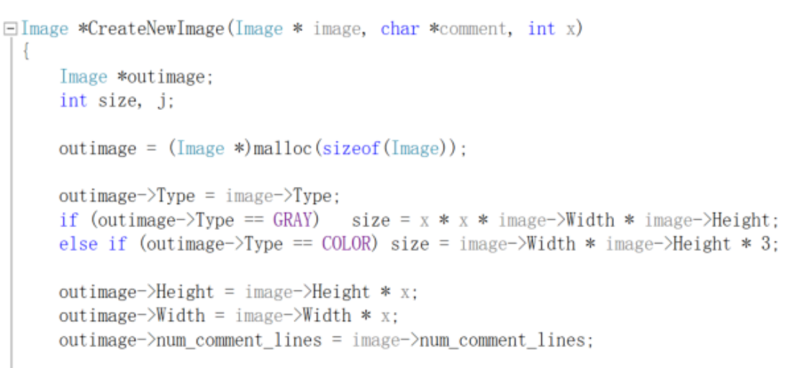 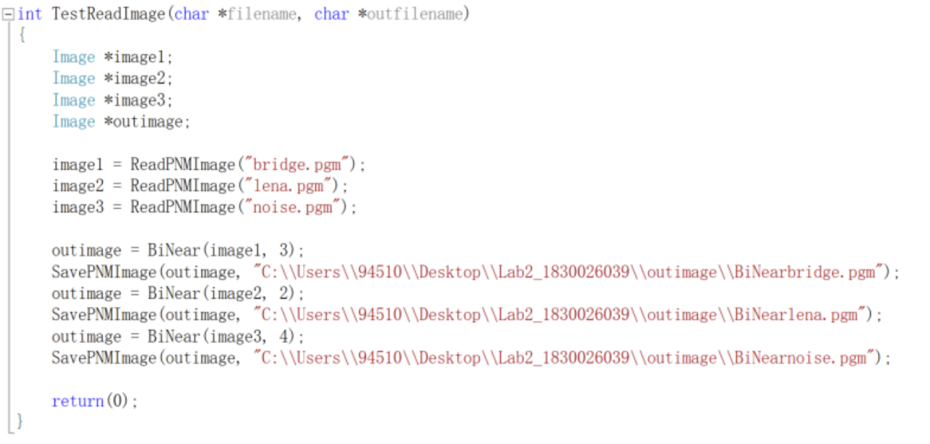

* Fractional linear expansion to expand images to any larger size

**Algorithm:**

It is the same as the nearest neighbor interpolation algorithm, except that the input value becomes a float, making it a fractional multiple. The calculation formula is:

FLR(image, h, w) //h and w are the reduced magnification of height and weight.

integer i from 0 to height/num, i plus 1,

integer j from 0 to width/num, j plus 1,

$$outData[i*outimageWidth+j]=indata[round(i*ratioH)*width+ratioW*j]$$

**Results (including pictures):**

Result of processing “Lena.pgm”:

Source Image:



Result after fractional linear expansion: (height: 1.5, width: 3.5)

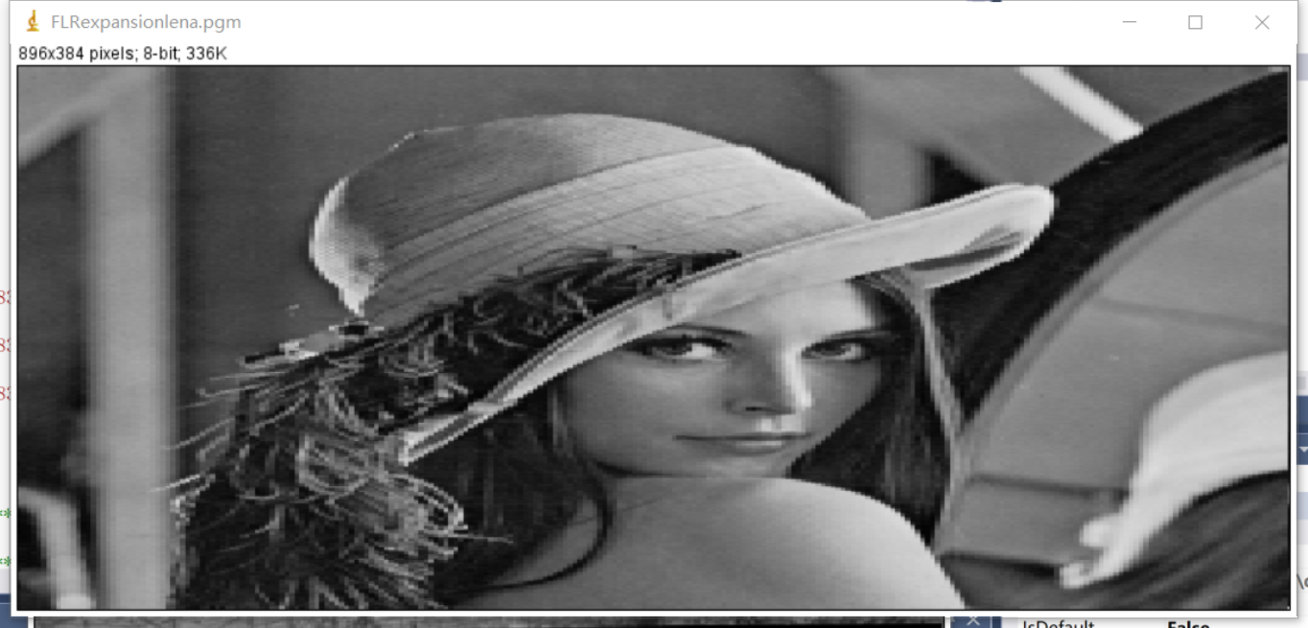

Result of processing “bridge.pgm”:

Source Image:



Result after fractional linear expansion: (height: 1.5, width: 2.5)

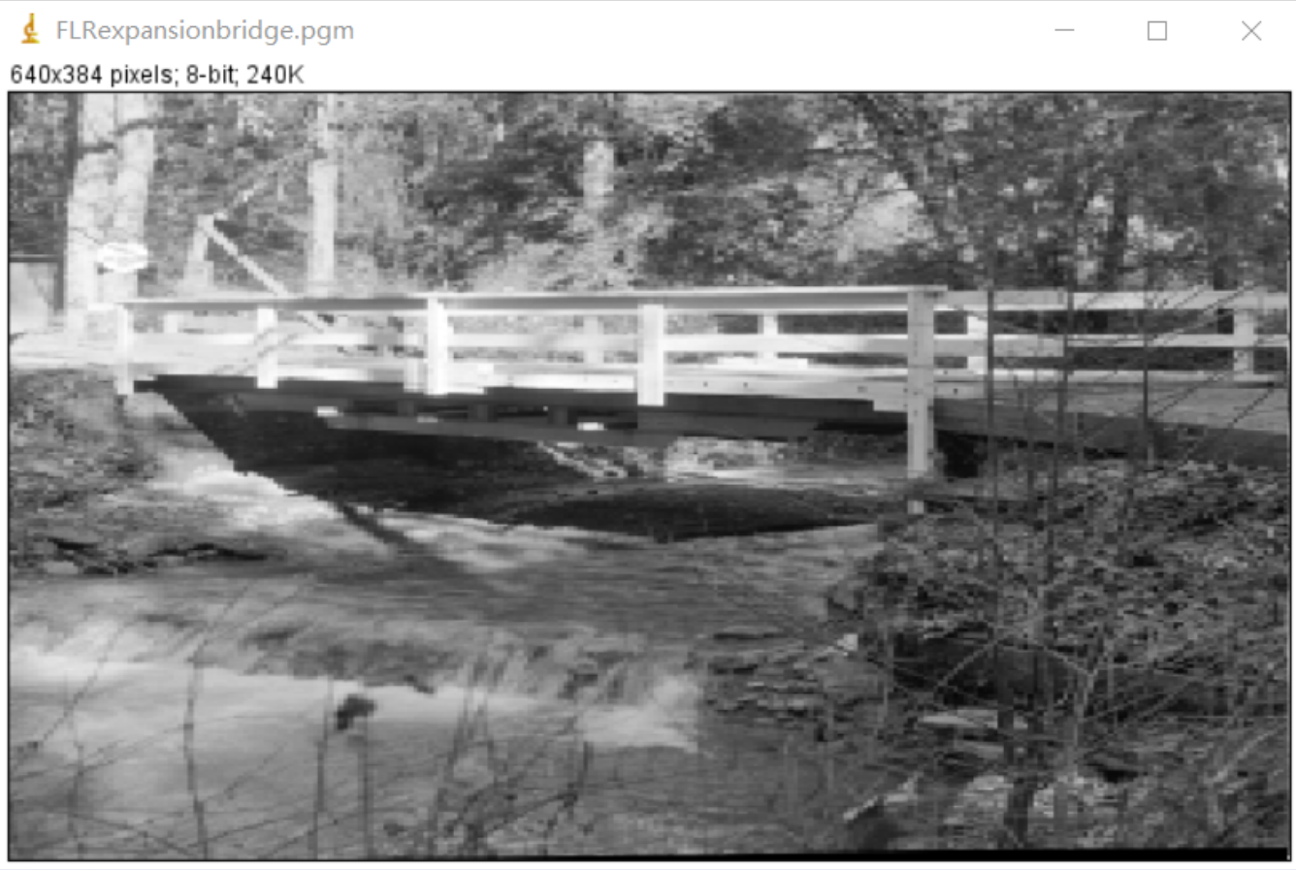

Result of processing “noise.pgm”:

Source Image: Result after fractional linear expansion:

(height: 1.2, width: 1.2)

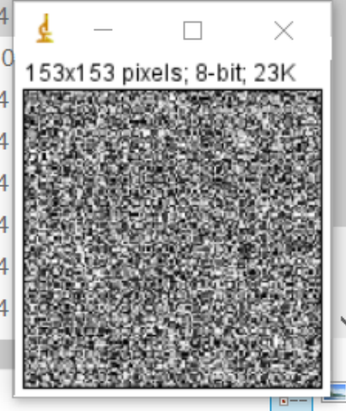

**Discussion:**

This algorithm is the same as the nearest neighbor interpolation algorithm, except that this algorithm can adjust the length and width separately, and can be a fractional multiple. The nearest neighbor interpolation calculation is relatively small, but it may cause discontinuities in the gray level of the image generated by the interpolation, and obvious jaggedness may appear at the place where the gray level changes.

**Codes:**

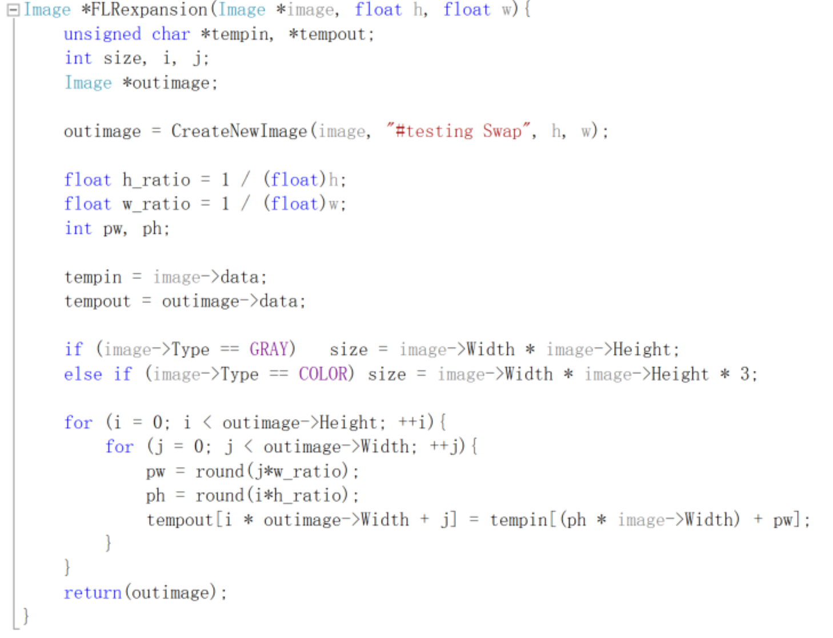 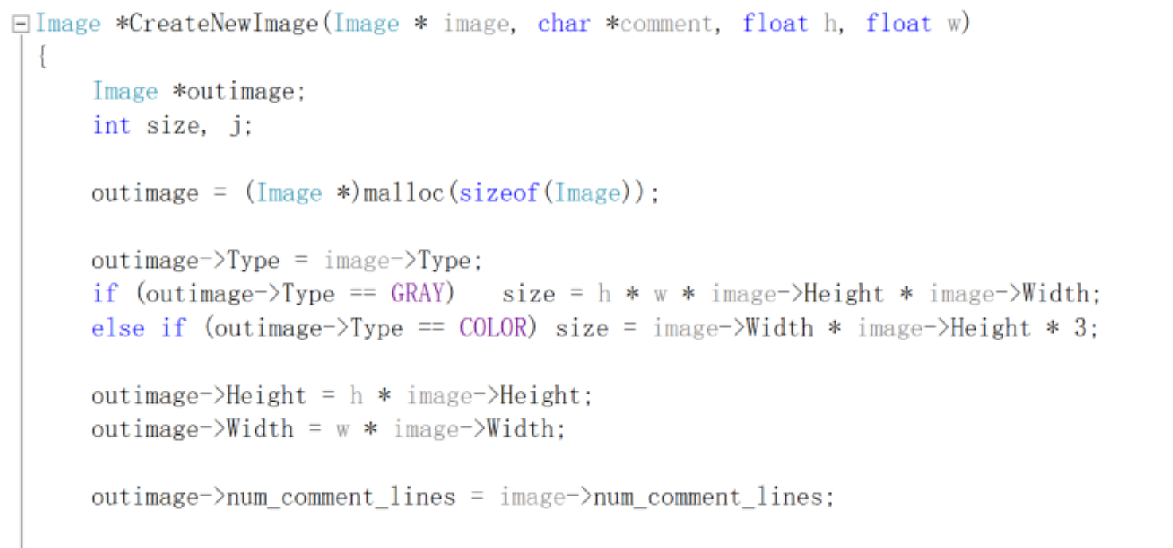 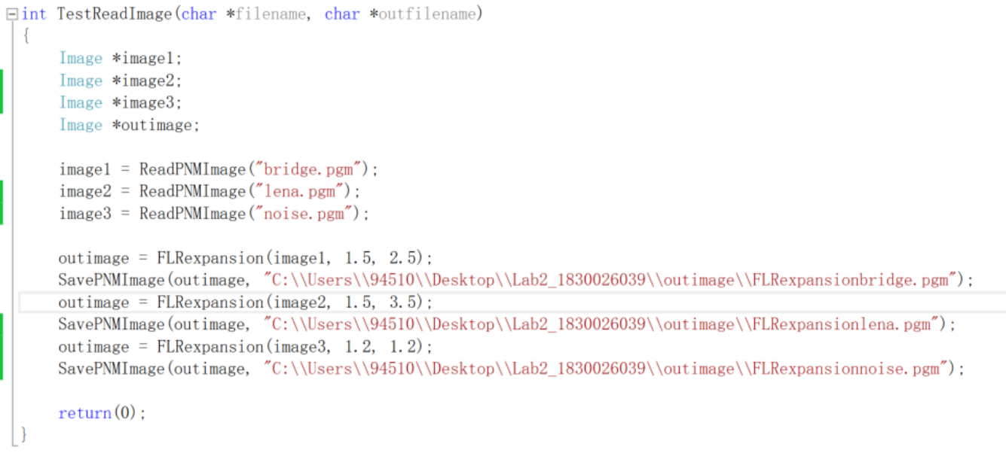

1. **Perform negative image operation:**

* On gray images

**Algorithm:**

Invert the grey image means change the grey level of an image using (255 – grey level) i.e. if grey level of a pixel is 150 then grey level in negative image is (255 – 150) = 105. It means 255 will changes with 0 and 0 will change with 255. It is changing of proportion of black and white present in grey.

**Results (including pictures):**

Result of processing “Lena.pgm”:

Source Image: Result after negative function:

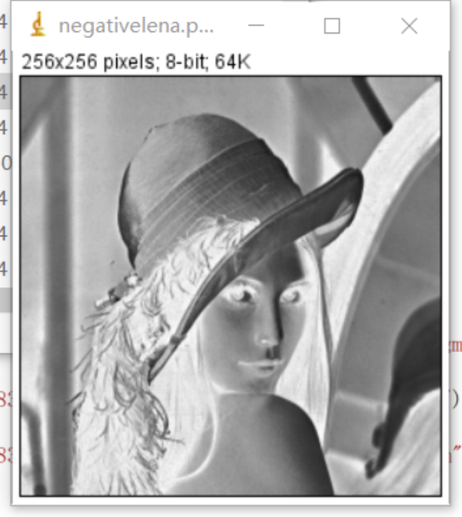

Result of processing “bridge.pgm”:

Source Image: Result after negative function:

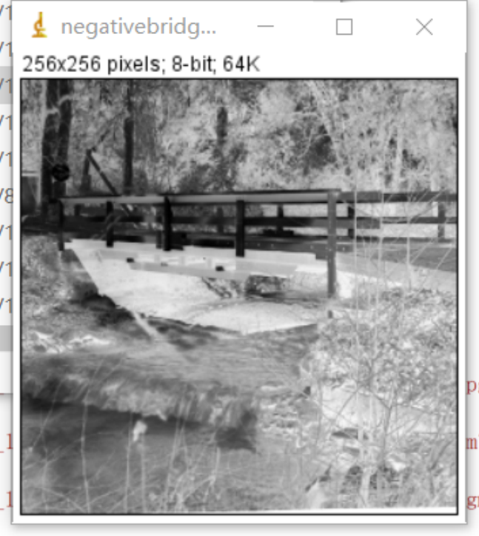

Result of processing “noise.pgm”:

Source Image: Result after negative function:

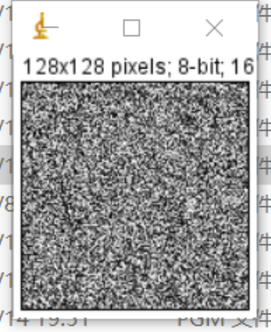

**Discussion:**

Negative image refers to the method of changing each gray value in the source image point by point according to a certain transformation relationship according to a certain target condition. The purpose is to improve the picture quality and make the image display clearer. It is a very basic and direct spatial image processing method in image enhancement processing technology, and it is also an important part of image digitization software and image display software.

**Codes:**

